Project Design Phase-II
Data Flow Diagram & User Stories

Date | 31 January 2026
Team ID | LTVIP2026TMIDS38297
Project Name | Gemini Historical Artifact Description
Maximum Marks | 4 Marks

Data Flow Diagram (DFD) - Level 0 (Context Diagram)
Instead of an image, I will describe the flow clearly so you can visualize or draw it:
- User sends Artifact Query (Name or Image) -> WebApp (Streamlit)
- WebApp sends Structured Prompt + Image Data -> Gemini AI Service
- Gemini AI Service processes data and sends back Generated Description (Text) -> WebApp
- WebApp formats data and displays Artifact Analysis Report -> User
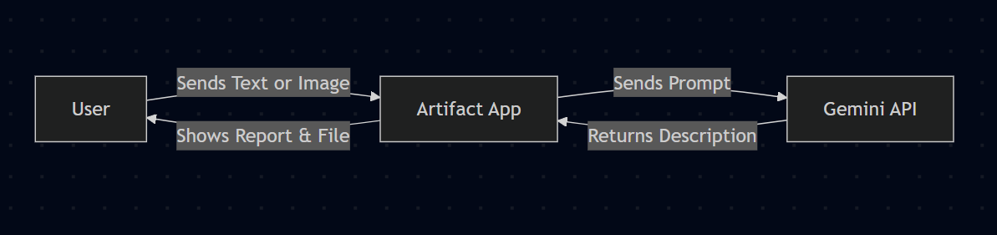
- User requests Download -> WebApp generates .txt/.md File -> User

User Stories
User Type | Functional Requirement (Epic) | User Story Number | User Story / Task | Acceptance Criteria | Priority | Release
History Enthusiast | Artifact Research | USN-1 | As a user, I want to enter an artifact's name to get a detailed historical description. | I can type a name, click "Generate", and see a structured report with background, facts, and significance. | High | Sprint-1
 |  | USN-2 | As a user, I want to upload an image of an artifact to identify and analyze it. | I can upload a JPG/PNG, and the AI correctly identifies the object and provides its history. | High | Sprint-1
 |  | USN-3 | As a user, I want to adjust the length of the description (Short/Long) to suit my reading time. | I can use a slider to select between 500-2000 words and the output length changes accordingly. | Medium | Sprint-2
 | Content Management | USN-4 | As a user, I want to download the analysis as a text or markdown file. | I can click a "Download" button and save the report to my device. | Medium | Sprint-1
 | Engagement | USN-5 | As a user, I want to see a random "Did You Know?" fact in the sidebar. | Every time I load the app or refresh, a new historical fact is displayed in the sidebar. | Low | Sprint-2
Museum Curator | Presentation | USN-6 | As a curator, I want the interface to look professional and museum-themed (dark/gold). | The app uses a specific color palette (Terracotta/Dark) and fonts (Serif) that feel premium. | High | Sprint-1
Administrator | System Config | USN-7 | As an admin, I want to configure the Google API key securely. | The app runs using an API key stored in  .env  or Streamlit secrets without hardcoding it. | Critial | Sprint-1

